Required Corrections & Design Improvements (As Observed in PDF)
- Page Overflow Issue
  - The report card is extending to 3 pages instead of 2.
  - Fix this by reducing the size and spacing of the “Student Distribution” cards so that the content fits within two pages.
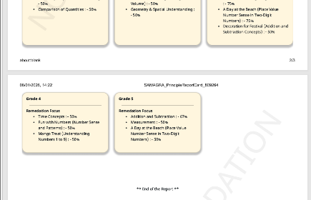
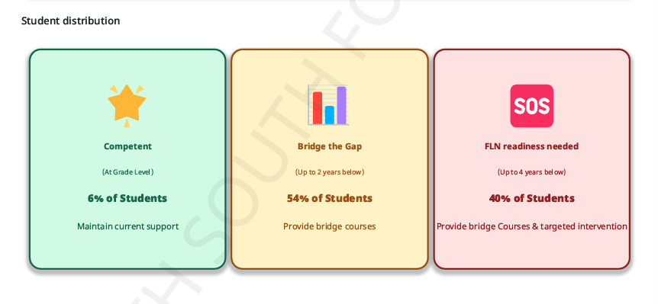
- NSF Competency Program Alignment
  - The “NSF Competency Program (NCP)” header and logo (top section on page 1) should be center-aligned horizontally.

- Gradient Color Usage
  - Replace the current half-filled / segmented color fills in cards and tables with fully filled gradient colors.
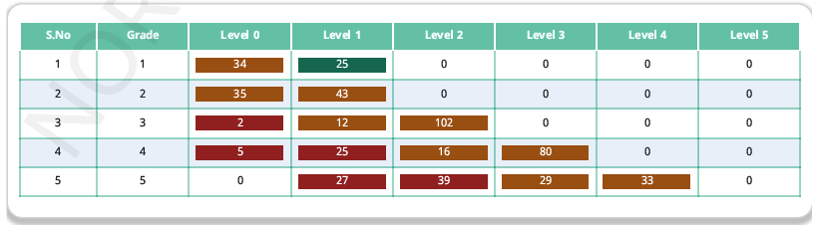
- Remove Serial Numbers (S.No)
  - Remove the “S.No” column from:
    - Participation Overview table
    - Subject-wise Learning Level Distribution tables (English & Mathematics)
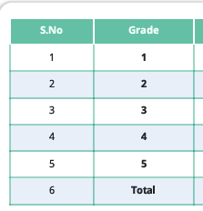
- Learning Level Mapping Correction
  - Students who have passed Grade 4 should be correctly reflected under Level 5 in the learning level distribution tables (where applicable).
- Highlight section Headings Clearly
  - Improve visual emphasis by highlighting table headers and section titles (bold text).
Ex. “Participation Overview” and “Student Distribution Tables”

- Main Heading Layout Enhancement
  - At the top of the report, clearly display:
    - “School Performance Report for Principals” (main heading)
    - School Name, Grades, Total Registered, Total Participation
  - These should appear as a single, well-structured main header block.
- Zero-Value Display Rule
  - In the Learning Level Distribution tables, replace 0 with “-” for grades where that learning level does not exist.
- Participation Data Mismatch
  - There is a data inconsistency between:
    - Total Registered & Total Participation (header section)
    - In the 1 – 5th grade report card there is entire school registration and participation count., please rectify.
  - These values must be revalidated and made consistent across the report.
- “Assessment Name” & “Date of Assessment” should be added in the header.
- Remediation focus should be referred to as “Areas of improvement” (Already specified).

- Which logic was used in Learning Level Distribution by Grade

